Project Documentation
Project Title: Implement Client Script & UI Policy (Incident)
Introduction:
- Project Title: Implement Client Script & UI Policy (Incident)
- Team ID: SWTID-2026-8393
- Team Leader: PALANI PRABA D (palanipraba15@gmail.com)
- Team Members:
1)NAVMITHA AFRIN S (navmithaafrin@gmail.com)
2)JAYAVARTHINI T (jayavarthinitheivendran@gmail.com)
3)SAHANA PARVEEN H (parveensahana821@gmail.com)
4)ABINAYA R (abinaya8648@gmail.com)
Problem Statement
Incident records require proper data entry and validation to maintain accurate and consistent information. Manual checking can result in incomplete or incorrect Incident details. Therefore, UI Policies and Client Scripts are used to control field behaviour, automate values, and validate Incident records before submission.
Objective
The objective of this project is to implement UI Policies and Client Scripts on the Incident table in ServiceNow. The project focuses on making fields mandatory, controlling field behaviour, automatically setting Urgency, validating Incident submission, and preventing unwanted State changes through list editing.
Skills
Incident Management
Client Scripts
onChange Client Script
onSubmit Client Script
onCellEdit Client Script
Form Validation
ServiceNow Configuration
Task 1: Create UI Policy on Incident
Step 1: I opened System UI → UI Policies and created a new UI Policy.
Step 2: I entered High Impact Control as the name and selected Incident as the table.
Step 3: I configured the condition as Impact is 1 – High.
Step 4: I configured the required UI Policy Action and enabled Mandatory with Reverse if false.
Step 5: I clicked Submit and saved the UI Policy.
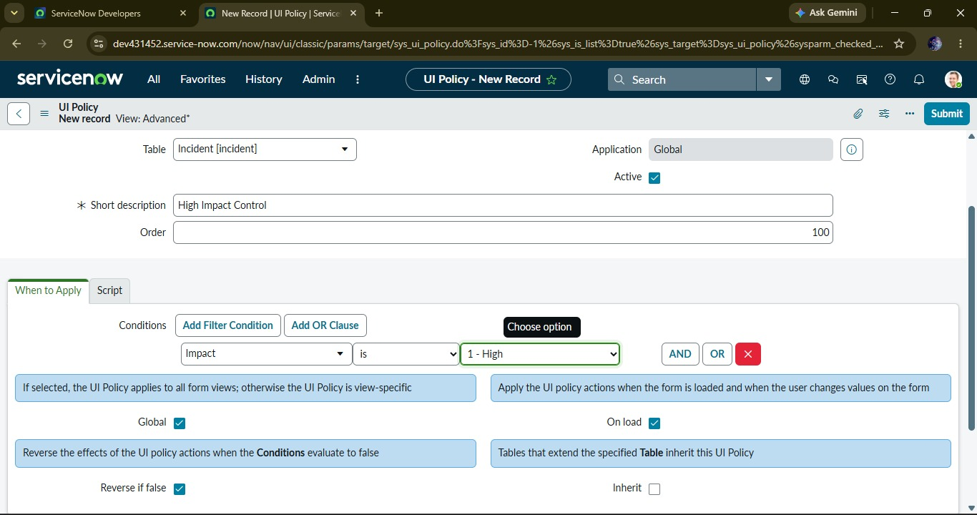
Task 2: Create UI Policy Action – Urgency
Step 1: I opened the High Impact Control UI Policy and created a new UI Policy Action.
Step 2: I selected Urgency as the field and enabled Read-only.
Step 3: I submitted the configuration and saved the UI Policy Action.
Step 4: I tested the Incident form with Impact = High and verified the Urgency field behaviour.
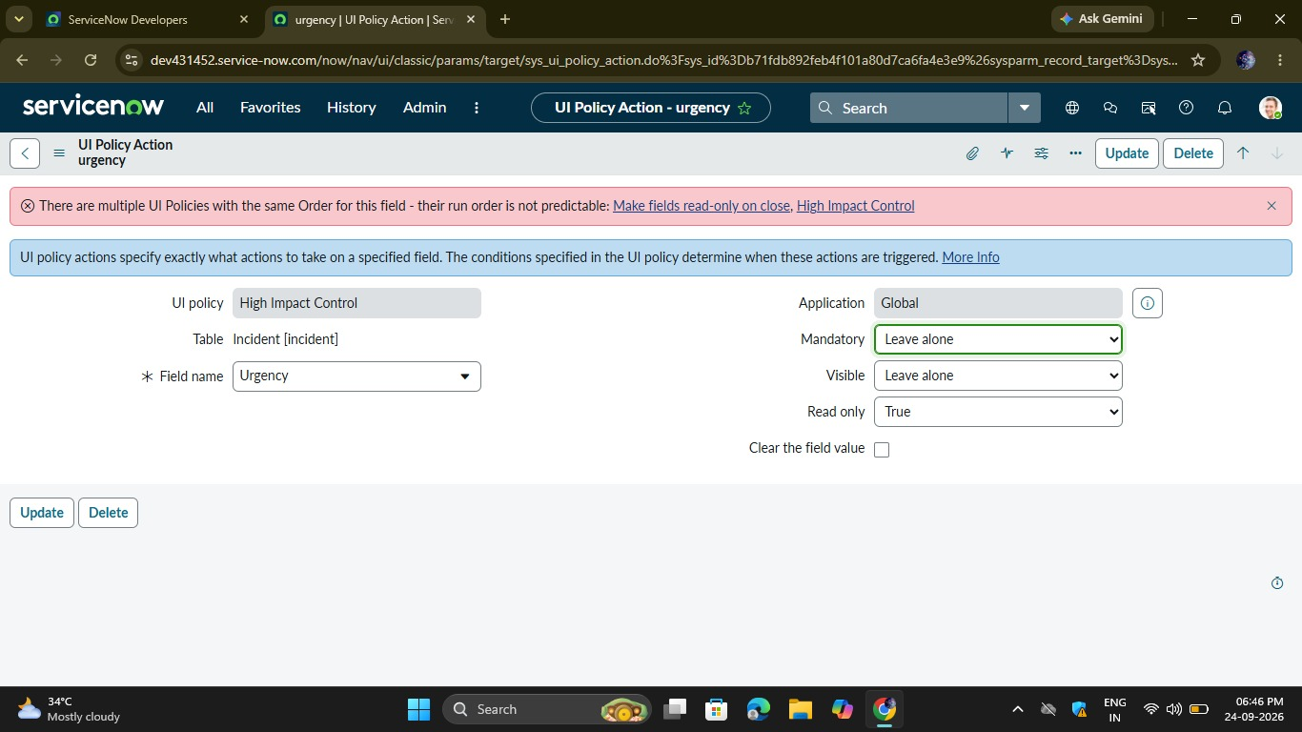
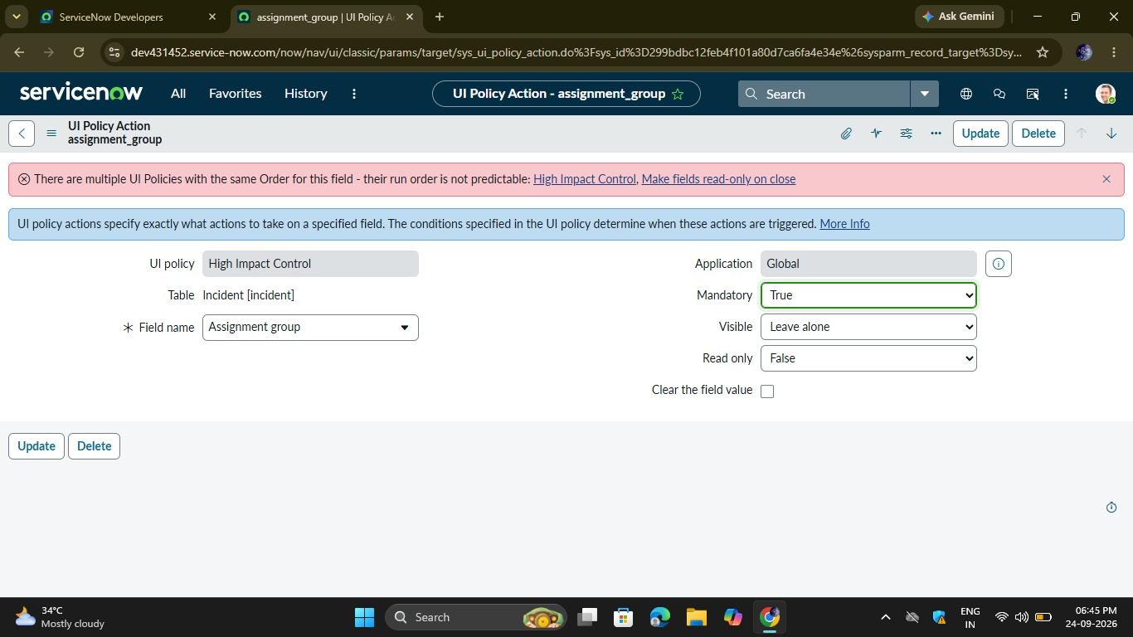
Task 3: Create onChange Client Script
Step 1: I opened System UI → Client Scripts and created a new Client Script.
Step 2: I configured it with Incident table, onChange type, and Impact as the field.
Step 3: I added the script to automatically set Urgency to High when Impact is High.
Step 4: I submitted the Client Script and tested it on an Incident record.
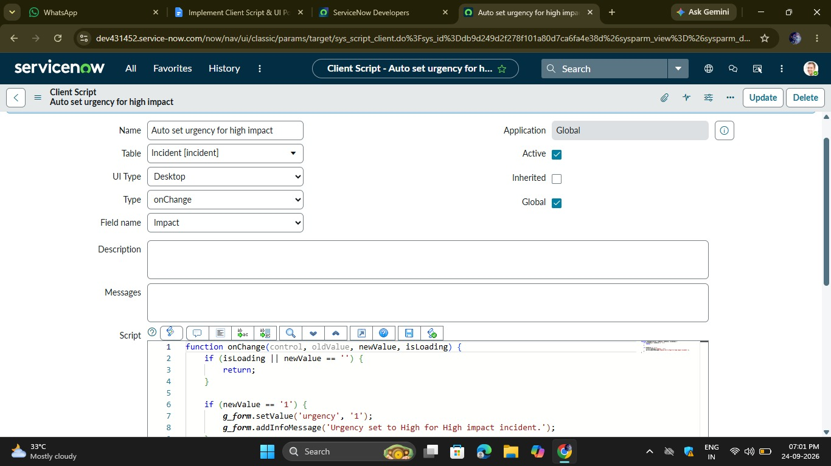
Task 4: Create onSubmit Client Script
Step 1: I created a new Client Script with Incident as the table and onSubmit as the type.
Step 2: I added the validation script to check whether Assigned To is empty when Impact is High.
Step 3: I submitted the Client Script and saved the configuration.
Step 4: I tested the Incident form and verified that the record could not be submitted without Assigned To.
Task 5: Create onCellEdit Client Script
Step 1: I created a new Client Script for the Incident table with onCellEdit type.
Step 2: I selected State as the field to control.
Step 3: I added the script to prevent State changes through list editing.
Step 4: I submitted the Client Script and tested the Incident list.
Step 5: I verified that State could not be changed directly from the list.
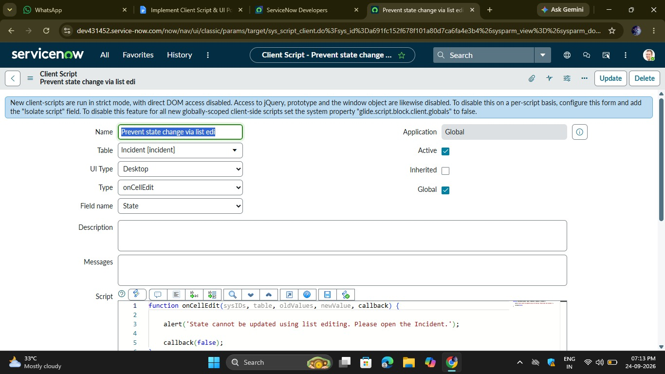
Task 6: Testing the Configuration
Activity 1: Test Mandatory Enforcement
Step 1: I created a new Incident and selected Impact = High.
Step 2: I left Assigned To empty and clicked Submit.
Step 3: I verified that the Incident was not saved and the validation message was displayed.
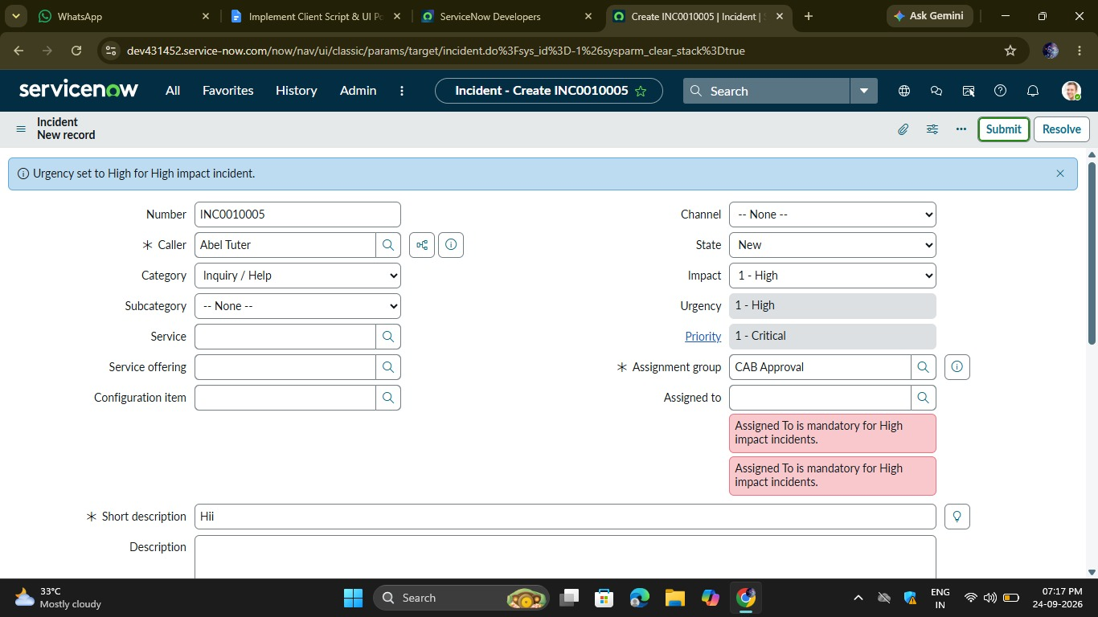
Activity 2: Test Successful Save
Step 1: I selected a user in Assigned To and submitted the Incident.
Step 2: I verified that the Incident was saved successfully.
Step 3: I confirmed that the configured Urgency and UI Policy behaviour worked correctly.
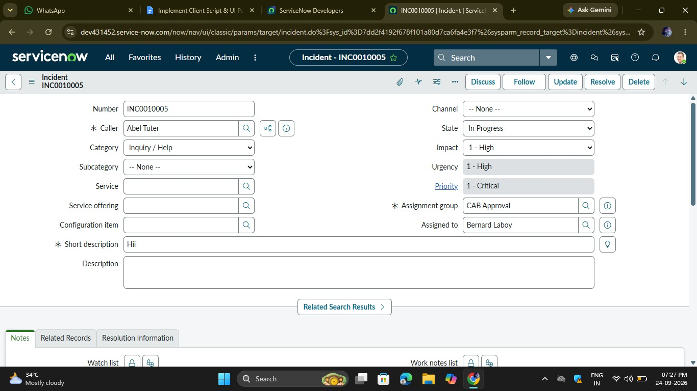
Activity 3: Reverse Condition Test
Step 1: I opened an Incident with Impact = High and changed it to Medium.
Step 2: I verified that the mandatory and read-only conditions were reversed.
Step 3: I saved the Incident successfully.
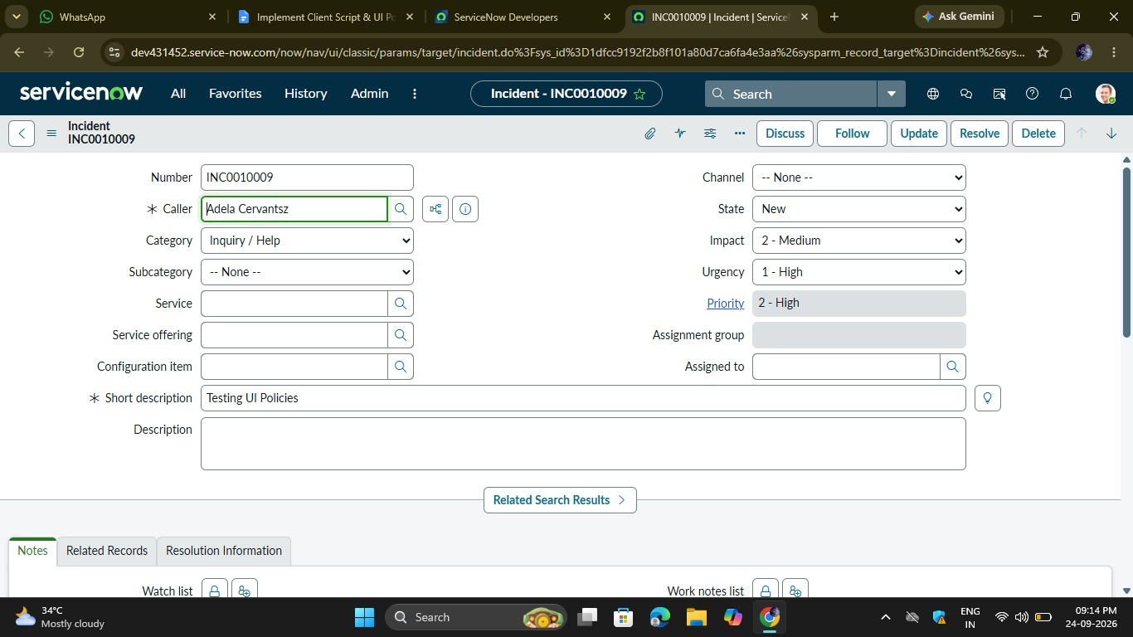
Activity 4: Test List Edit Blocking
Step 1: I opened Incident → All and tried to edit the State directly from the list.
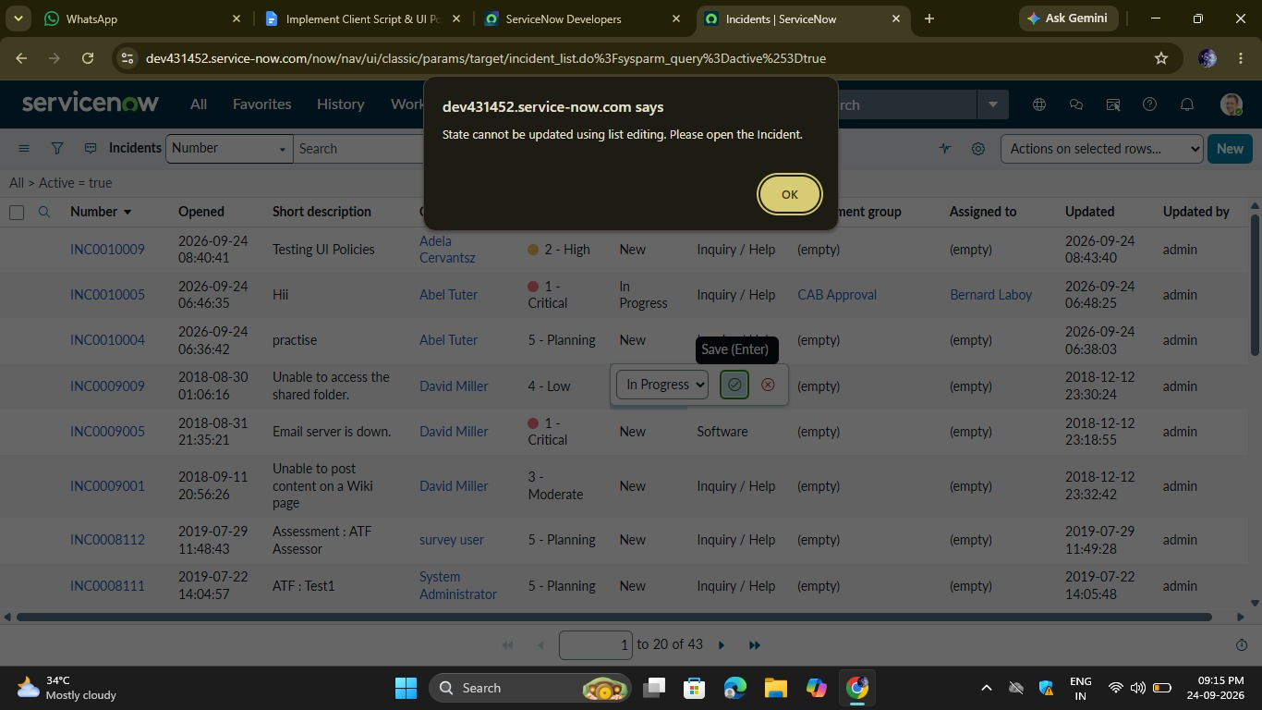
Step 2: I verified that the alert message appeared and the State was not changed.
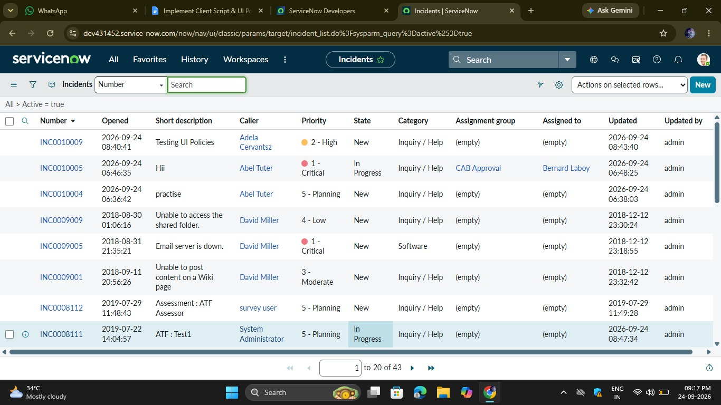
Activity 5: Test Form-Based Update
Step 1: I opened the Incident form and changed the State field.
Step 2: I clicked Update and verified that the State change was saved successfully.
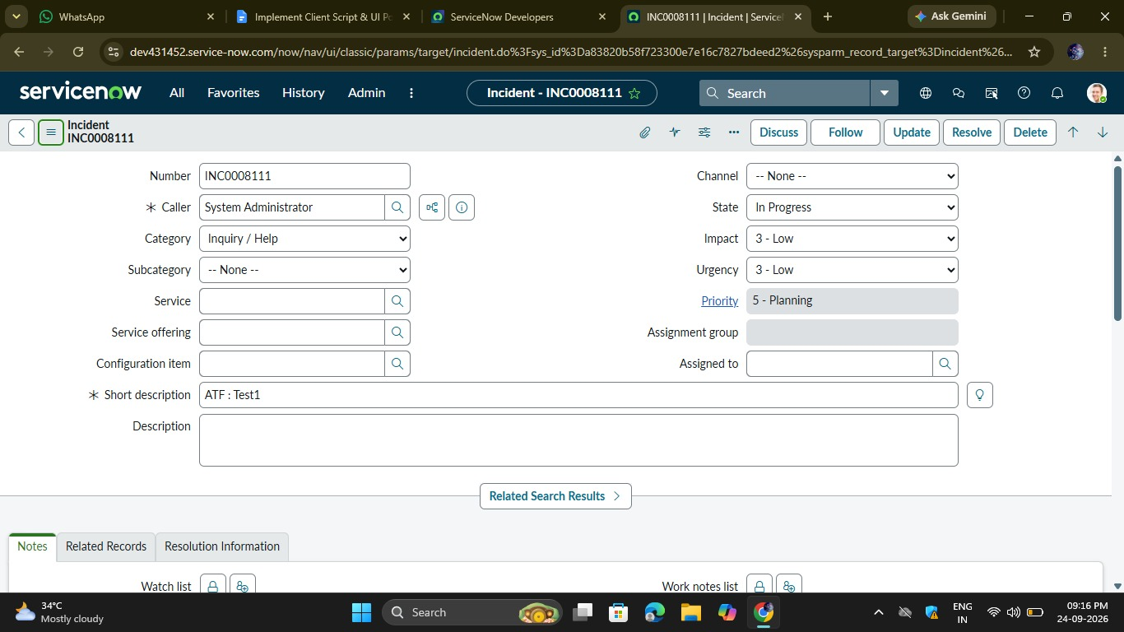
Demo Video Link: https://drive.google.com/file/d/1WjDkl2ircIX5ERffwwDvGg3w_912Gd6W/view?usp=drivesdk
Conclusion
The Implement Client Script & UI Policy (Incident) project was completed successfully in ServiceNow. UI Policies and Client Scripts were configured and tested to control Incident fields based on the Impact value. The project also verified mandatory field validation, automatic Urgency updates, State restrictions, and successful form-based updates.

